# A

# MAJOR PROJECT REPORT

**ON**

# “AUTONOMOUS CAR USING LIDAR”

Submitted for partial fulfilment of the award

**BACHELOR OF TECHNOLOGY**

IN

# ELECTRONICS & COMMUNICATION ENGINEERING

**2018-22**

Aman Saifi (1814431010)

Anirudh Manoj (1814431011)

Ashish Chaudhary (1814331018)

**Guided by:**

**Dr. Neeraj Jain**

**(Assistant Professor)**

**IMS ENGINEERING COLLEGE: GHAZIABAD**



**Dr. A.P.J. ABDUL KALAM TECHNICAL UNIVERSITY, LUCKNOW**

**JUNE 2022**

**DECLARATION**

We here with declare that this submission is our work which to the most effective of our knowledge & belief, it contains no material antecedent revealed or written by another person nor material that to a considerable extent has been accepted for the award of the other degree of the university or another institute of upper learning, except wherever due acknowledgment has been created within the text.

Name: Aman Saifi

Roll No: 1814331010

Name: Anirudh Manoj

Roll No: 1814331011

Name: Ashish Chaudhary

Roll No: 1814331018

**CERTIFICATE**

Certified that Aman Saifi, Anirudh Manoj, and Ashish Chaudhary have carried out the work presented in this project entitled “**AUTONOMOUS CAR USING LI-DAR”** for the award of **Bachelor of Technology** from Dr. A.P.J. Abdul Kalam Technical University in Lucknow under my supervision. The result of original work is personified and studies carried out by students themselves and along with the contents of the project don’t form the basis for any award of any other degree to the candidate or to anybody else**.**

Date: (**Dr. Neeraj Jain)**

Assistant Professor

ECE Dept., IMSEC

**ACKNOWLEDGMENT**

It gives us a great sense of pleasure to present the report of the B. Tech project undertaken at B. Tech Final Year. We owe a special debt of gratitude to Dr. Neeraj Jain, Assistant Professor in the Department of Electronics and Communication Engineering, IMS Engineering College, Ghaziabad for his constant support and guidance throughout the course of our work. His sincerity, thoroughness, and perseverance have been a constant source of inspiration for us. It is only through his cognizant efforts that our endeavors have seen the light of the day.

I am deeply thankful to **Prof. Jyoti Guglani**, H.O.D., Department of Electronics and Communication Engineering for their motivation and inspiration. We don’t like to miss any opportunity to acknowledge the contribution of all the faculty members of the ECE department for their kind assistance & contribution during the development of our project. Last but not the least, we acknowledge our team members for their contribution to the completion of the project.

Name: Aman Saifi

Roll No:1814331010

Name: Anirudh Manoj

Roll No:1814331011

Name: Ashish Chaudhary

Roll No:1814331018

**ABSTRACT**

Robotics is a branch of science that deals with Automatic, Electrical and Software fields. Robots are the machines that are used in our day-to-day to life to decrease men power and work accurately without any distortions. Robots can be classified into two different sections basing upon their skills as Automated and Manual. Obstacle detector is an Automated robot which itself recognizes the obstacle in its path and moves in free direction. Robot detects the obstacle by using two IR Sensors placed in front.

The IR sensors are placed on left and right side of the robot through which continuous Infrared radiation is emitted for detection of obstacles in the path. These IR Sensors are connected to a controlling element AT89c51 µc. When an obstacle is placed in the path of robot IR beam is reflected to the sensor from the obstacle. On detecting obstacle in the path sensor sends 0 volts to µc. These 0 voltages are detected by Microcontroller which avoids the obstacle by taking left or right turn. Similarly, if the sensor sends +5v to Microcontroller, the Microcontroller assumes it as clear path and makes the robot to move in straight. Two motors namely right motor and left motor are connected to Motor driver IC (L293D). L293D is interface with Microcontroller. Microcontroller sends logic 0 & logic 1 as per the programming to driver IC which makes motors to rotate in clockwise and anticlockwise direction. Wheels attached to the motors rotate accordingly with the motor shaft causing in the moment of the robot by wheels. In front portion of the robot a free wheel is attached to move the robot easily in any direction as per the requirement.

A 12Volts DC battery is attached to the circuit. As the microcontroller and sensors requires only 5v, set of resistors and capacitors are used to supply 5v DC to them. Power Management System is not maintained in the circuit as the battery can be removed after the usage of robot. So, it does not cause any loss in the power of battery.

This type of robots has multiple applications in various fields. They can be used to know the strength of the opposite army in defense system. They can be used as floor and wall cleaners. They are used in automated GPS vehicles to calculate the moment of the vehicle overhead. These robots are easy to construct and cheaper in cost with long durability.

**LIST OF TABLES**

|  |  |  |
| --- | --- | --- |
| **Chapter**  **No.** | **Particular** | **Page**  **No.** |
| **i.** | Declaration | 2 |
| **ii.** | Certificate | 3 |
| **iii.** | Acknowledgment | 4 |
| **iv.** | Abstract | 5 |
| **v** | Table of content | 6 |
| **vi** | List of figures | 7 |
|  |  |  |
| **Chapter - 1** | **Introduction** |  |
| **1.1** | INTRODUCTION | **9** |
| **1.2** | CHARACTERSTICS | 10 |
| **1.3** | TYPES OF EMBEDDED SYSTEM | 11 |
| **1.4** | APPLICATIONS | 12 |
|  |  |  |
| **Chapter 2** | INTRODUCTION | 13 |
| 2.2 | WORKING OF PROJECT | 14 |
| 2.3 | BLOCK DIAGRAM DESCRIPTION | 15 |
| 2.4 | MICROCONTOLLER ATMEGA328p | 16-18 |
|  |  |  |
| **Chapter 3** | **HARDWARE IMPLIMENTATION** | 19 |
| 3.1 | SCHEMATIC DIAGRAM | 19 |
| 3.2 | CIRCUIT DESCRIPTION | 20-26 |
| 3.3 | HARDWARE MODULES | 27-30 |
| 3.4 | Applications | 30-37 |
|  |  |  |
| **Chapter 4** | Tools |  |
| 4.1 | SOFTWARE TOOL REQUIRED | 38 |
| 4.2 | PROGRAMING MICROCONTROLLER | 38 |
| 4.3 | KEIL Compiler | 39 |
| 4.4 | PROLOAD | 39 |
| 4.5 | FEATURES | 40 |
| 4.6 | CODING | 41-45 |
|  |  |  |
| **Chapter 5** | FUTURE SCOPE & RESULT |  |
| 5.1 | FUTURE SCOPE | 46 |
| 5.2 | RESULT & CONCLUSION | 47 |
| 5.3 | Project photos | 48 |
|  |  |  |
| **Chapter 6** | REFERENCES | **49** |
| Appendix | Plagiarism Report | 50 |
| Appendix | Research Published paper | 51-57 |

**List of Figures**

|  |  |  |
| --- | --- | --- |
| **1** | Fig 1.1: Embedded System | 9 |
| **2** | Fig 1.2 Embedded in Automobile | 11 |
| **3** | Fig 1.3 Smart Cards | 11 |
| **4** | Fig 1.4: Computers and peripherals | 12 |
| **5** | Fig 2.1 Level of Automation | 13 |
| **6** | Fig 2.2 Block Diagram of the Project | 14 |
| **7** | Fig 2.3: LI-DAR Sensor. | 15 |
| **8** | Fig 2.5: A lidar map of Lynnhaven Inlet, Virginia | 16 |
| **9** | Fig 2.6: Atmega 328p microcontroller | 17 |
| **10** | Fig 2.7: Motor Driver Module | 17 |
| **11** | Fig 2.8: DC motor | 17 |
| **12** | Fig 3.1 Schematic Diagram | 18 |
| **13** | Fig 3.2 Internal Diagram | 18 |
| **14** | Fig 3.3 Components of a Typical Linear power Supply | 19 |
| **15** | Fig 3.4 IC | 20 |
| **16** | Fig 3.5 circuit Diagram | 20 |
| **17** | Fig 3.6: Arduino UNO | 21 |
| **18** | Fig 3.7 Sensor | 22 |
| **19** | Fig 3.8 Lithium Battery | 23 |
| **20** | Fig 3.9 Schematic of a lithium-ion battery | 24 |
| **21** | Fig 3.10 Lidar Sensor | 25 |
| **23** | Figure: 3.11 Pin diagram | 27 |
| **24** | Fig 3.12 Internal diagram of microcontroller | 30 |
| **25** | Fig 3.13 Internal working of Motor | 31 |
| **26** | Fig 3.14 Motor Driver Module | 34 |
| **27** | Fig 3.15 Internal circuit diagram of L298N Motor Driver module is given | 35 |
| **28** | Fig 3.16 Dc motor Control 1 | 36 |
| **29** | Fig.4.1 Compilation source code | 38 |
| **30** | Fig 4.2 Proload Software | 39 |
| **31** | Fig 5.1 Project photo 1 | 47 |
| **32** | Fig 5.2 Project Photo 2 | 47 |

**CHAPTER 1**

**INTRODUCTION**

An embedded system is a computer system planned to perform one or a few dedicated roles often with real-time computing constraints. It is embeddedis part of a complete device which includes hardware and mechanical parts. By contrast, a general-purpose computer, such as a personal computer (PC) and many more, is designed to be flexible and to meet a wide range of end-user needs. Embedded systems control one or more devices in common use today.

Embedded systems are controlled by one or more than one main processing cores which is typically either a microcontroller or a digital signal processor (DSP). It is basically dedicated to handle a particular task, which may require very powerful processors. The embedded system is dedicated to specific tasks, design engineers can optimize it by reducing the size and cost of the products and increasing the reliability and performance of the embedded system.

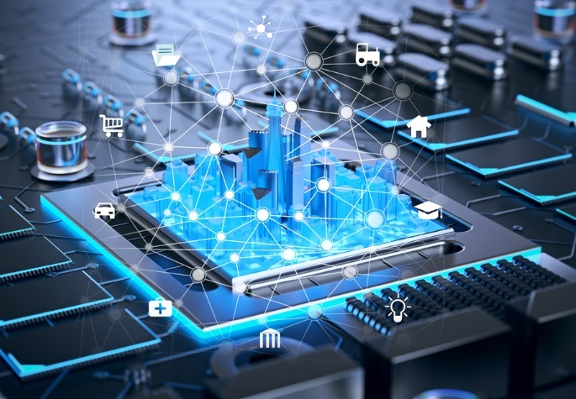

Fig 1.1: Embedded System

# CHARACTERISTICS

* + 1. Embedded systems are designed to do some specific task, rather than be a general-purpose computer for multiple tasks. Some also have real-time performance constraints which must meet the requirements, for reasons like safety and usability others might have low or no performance requirements, allows the system hardware to be simplified to reduce costs.
    2. Embedded systems are not always stand-alone devices. Many embedded systems consist of small, computerized parts within a larger device that serves a more general purpose.
    3. The program instructions written for embedded systems are referred to as firmware, and are stored in read-only memory or Flash memory chips. They work (run) with limited computer hardware resources: little memory, small or non-existent keyboard and/or screen.

# TYPES OF EMBEDDED SYSTEM;

* Stand-alone embedded systems
* Real time embedded systems
* Networked embedded systems
* Mobile embedded systems

# 1.4 APPLICATIONS:

Embedded controllers may be found in many different kinds of system and are used for many different applications such as:

* **Embedded Systems in Automobiles and in telecommunications**
* Motor and cruise control system
* Body or Engine safety
* Entertainment and multimedia in car
* E-Com and Mobile access
* Robotics in assembly line
* Wireless communication
* Mobile computing and networking

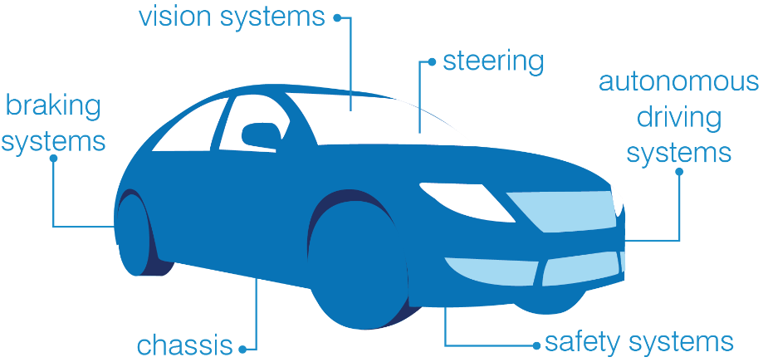

Fig 1.2 Embedded in Automobile

* **Embedded Systems in Smart Cards, Missiles and Satellites**
* Security systems
* Telephone and banking
* 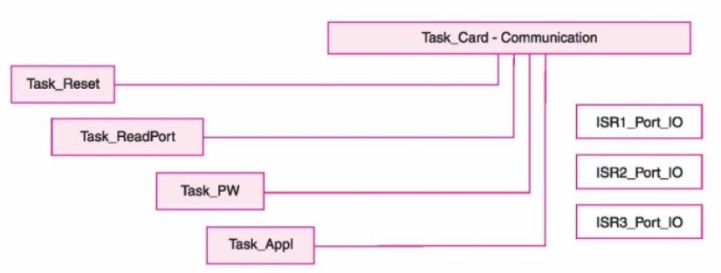Défense and aerospace
* Communication

Fig 1.3 Smart Cards

* **Embedded Systems in Peripherals & Computer Networking**
* Displays and Monitors
* Networking Systems
* Image Processing
* 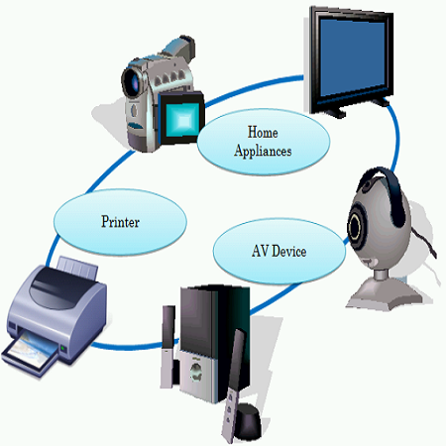Network cards and printers

Fig 1.4: Computers and peripherals

* **Embedded Systems in Consumer Electronics**
* Digital Cameras
* Set top Boxes
* High Definition TVs
* DVDs

# CHAPTER-2

**AUTONOMOUS CAR**

**2.1 INTRODUCTION**

This autonomous car is a vehicle which capable of sensing its environment and functioning without human involvement. A human passenger is not enforced to take control of the vehicle at any time, nor is a human passenger required to be present in the vehicle at all. An autonomous car can go anywhere a traditional car goes and do everything that an experienced human driver does and transportation accidents are in an extremely one amongst the numerous causes of death in the world. According to the report evident by the “World Health Organization (WHO)”, over one million fatalities are caused due to road accidents besides the numbers are even a lot of which integrates very little or major injuries. Most of the time accidents happen because of human mistakes. Humans attempt mistakes in frequent ways, such as using mobile phones while driving, distracted through billboards and deficiency of sleep results in drowsiness generally while driving. Consequently, in response to the above-mentioned conditions accidents occur. Therefore, there is a need for a solution that helps humans in safe driving.

Once the first guided car was introduced, leading to more enhancement and improvement in cars. Further, the vision guided car was introduced in 1988 with the use of Lidar (light detection and ranging uses eye-safe laser beams to “see” the world in 3D, providing machines and computers an accurate representation of the surveyed environment) and computer vision for tracking and obstacle detection and prevention. For around 20 years, “Uber”, “tesla”, “google”, “Toyota” are some of the manufacturers that have been designing and testing these cars and they had achieved good results while moving towards complete automation.

Beyond everyday use, self-driving cars could expand transportation options for the elderly and disabled and ease business travel by guiding drivers in unfamiliar locales. Achieving automotive car requires artificial intelligence to process and integrate data from a suite of sensors including UV sensor, laser lidar, LCD and a mobile camera installed with Droid Cam to view the surroundings. Each sensor in the suite has its strengths and weaknesses. Ultrasonic are good at sensing nearby objects, but too short-ranged for driving. Therefore, The Lidar sensor give the full accuracy in detecting the obstacles more accurately other than UV sensors. Also, the cameras are installed to show the local environment for patrolling and spying the environment to help also as the safety measure and protection for the passengers sitting in the autonomous.

We are about to reach to that future, a future in which our elder and disabled loved ones will be able to maintain their independence, where time spent commuting will be time spent doing what you want to do and where deaths from traffic accidents (over 2 million worldwide every year) will be reduced dramatically, since 94% of the accidents are due to human error.

Autonomous vehicles don’t drink alcohol nor take drugs, they are never tired or sick, they never take medicines, they never lose their concentration or talk by phone, they know how to drive since the first moment and don’t need to learn, they never act recklessly when driving. On the other hand, they will drive much more smoothly, they will pollute less and, if they have an accident, they will ask for help autonomously

The Society of Automotive Engineers (SAE) presently defines 6 levels of driving automation ranging from Level 0 (fully manual) to Level 5 (fully autonomous). These levels have been approved by the U.S. Department of Transportation.

* Level 0: The automated system issues warnings and may momentarily intervene but has no sustained vehicle control.
* Level 1 ("hands on"): The driver and the automated system share control of the vehicle. Examples are systems where the driver controls steering and the automated system controls engine power to maintain a set speed (Cruise control) or engine and brake power to maintain and vary speed (Adaptive cruise control or ACC); and Parking Assistance, where steering is automated while speed is under manual control. The driver must be ready to retake full control at any time. Lane Keeping Assistance (LKA) Type II is a further example of Level 1 self-driving. Automatic emergency braking which alerts the driver to a crash and permits full braking capacity is also a Level 1 feature, according to Autopilot Review magazine.
* Level 2 ("hands off"): The automated system takes full control of the vehicle: accelerating, braking, and steering. The driver must monitor the driving and be prepared to intervene immediately at any time if the automated system fails to respond properly. The shorthand "hands off" is not meant to be taken literally – contact between hand and wheel is often mandatory during SAE 2 driving, to confirm that the driver is ready to intervene. The eyes of the driver might be monitored by cameras to confirm that the driver is keeping their attention to traffic. Literal hands-off driving is considered level 2.5, although there are no half levels officially. A common example is adaptive cruise control which also utilizes lane keeping assist technology so that the driver simply monitors the vehicle, such as "Super-Cruise" in the Cadillac CT6 by General Motors or Ford's F-150 Blue Cruise.
* Level 3 ("eyes off"): The driver can safely turn their attention away from the driving tasks, e.g. the driver can text or watch a film. The vehicle will handle situations that call for an immediate response, like emergency braking. The driver must still be prepared to intervene within some limited time, specified by the manufacturer, when called upon by the vehicle to do so. You can think of the automated system as a co-driver that will alert you in an orderly fashion when it is your turn to drive. An example would be a Traffic Jam Chauffeur, another example would be a car satisfying the international Automated Lane Keeping Systems (ALKS) regulations.
* Level 4 ("mind off"): As level 3, but no driver attention is ever required for safety, e.g. the driver may safely go to sleep or leave the driver's seat. However, self-driving is supported only in limited spatial areas (geofenced) or under special circumstances. Outside of these areas or circumstances, the vehicle must be able to safely abort the trip, e.g. slow down and park the car, if the driver does not retake control. An example would be a robotic taxi or a robotic delivery service that covers selected locations in an area, at a specific time and quantities. Automated Valet Parking is another example.
* Level 5 ("steering wheel optional"): No human intervention is required at all. An example would be a robotic vehicle that works on all kinds of surfaces, all over the world, all year around, in all weather conditions.

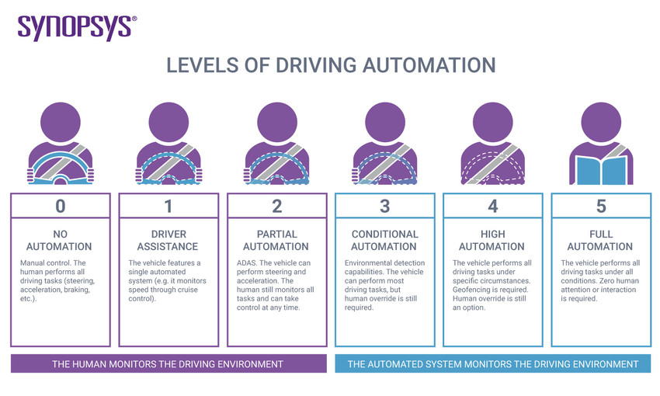

Fig 2.1 Level of Automation

* 1. **WORKING OF PROJECT**

When we switch on the car then Lidar and UV sensor get activated and sent pulse light beam aimed at an object and a sensor looks for its reflection. If beam is detected its intensity and angle is measured. There values are then plugged into an equation run by a microcontroller Atmega 328p.

Simultaneously, UV Sensor from both left and right also emits light from a transmitter, and then detects the light reflected back from the detection object with a receiver.

Their output values are also plugged into microcontroller atmega 328p. With the help of outputs and value provided by Lidar and UV sensor. Microcontroller instruct the vehicle for start, Stop, Move Forward, Slow Down, Turn Left and Right. Microcontroller Provide command to Motor Driver IC for Controlling Motors of a Vehicle and also the Lidar and both UV sensor measure the distance and show the output on the LCD. Also, the mobile placed over the robot helps in patrolling.

Autonomous vehicles/car don’t drink alcohol nor take drugs, these vehicles are never tired or sick, they never take medicines, they never lose their concentration or talk by phone, they know how to drive since the first moment and don’t need to learn, they never act recklessly while driving. On the other hand, they will drive much more smoothly, they will pollute less and, if they have an accident, they will ask for help autonomously.

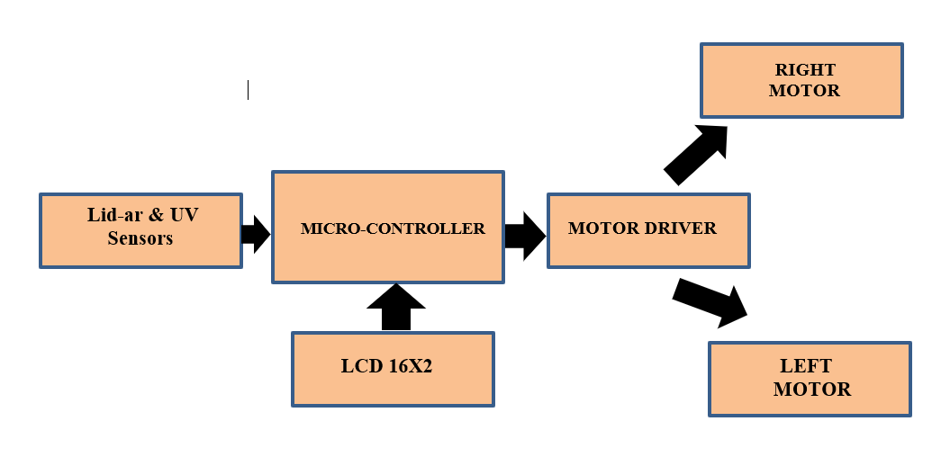

# BLOCK DIAGRAM:

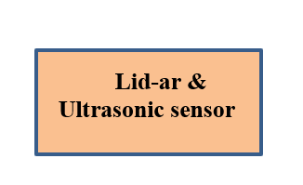

Fig 2.2 Block Diagram of the Project.

* 1. **BLOCK DIAGRAM DESCRIPTION:**
* Li-Dar Sensor
* Microcontroller AT89C52
* Motor Driver
* Motors
* Ultrasonic Sensor.

# LI-DAR SENSOR

# A typical lidar sensor (GP2Y0A21YK0F) emits pulsed light waves into the surrounding environment. Lidar, which stands for Light Detection and Ranging, is a remote sensing method that uses light in the form of a pulsed laser to measure ranges (variable distances) to the Earth. These light pulses—combined with other data recorded by the airborne system — generate precise, three-dimensional information about the shape of the Earth and its surface characteristics.

# A lidar instrument principally consists of a laser, a scanner, and a specialized GPS receiver. Airplanes and helicopters are the most commonly used platforms for acquiring lidar data over broad areas. Two types of lidar are topographic and bathymetric. Topographic lidar typically uses a near-infrared laser to map the land, while bathymetric lidar uses water-penetrating green light to also measure seafloor and riverbed elevations.

# 

# 

# Fig 2.3: LI-DAR Sensor.

# Lidar systems allow scientists and mapping professionals to examine both natural and manmade environments with accuracy, precision, and flexibility. NOAA scientists are using lidar to produce more accurate shoreline maps, make digital elevation models for use in geographic information systems, to assist in emergency response operations, and in many other applications.

# LIDAR image Lynnhaven Inlet, Virginia

# Fig 2.5: A lidar map of Lynnhaven Inlet, Virginia.

# COMPARISON BETWEEN SENSORS:

|  |  |  |  |  |
| --- | --- | --- | --- | --- |
| **Long Range radar** | **Ultrasound** | **Short/medium range**  **radar** | **Optical Cameras**  **communication** | **Lidar** |
| Microwave radar at 77Ghz has low resolution.  Radar takes more time to lock on an object.  Radar has a wider beam range (Over 50ft Diameter). | Short range, but that makes it the best choice for identifying close objects,  particularly for parking. Used in some parking assists systems today. Also, it spots the people close to the cars. | It cannot distinguish and resolve multiple targets which are very close like our eye. It cannot recognize colour of the targets. Radar takes more time to lock on an object. | The OCC technology does not support high data rate communication. This is due to low frame rates supported by traditional cameras. Image sensors support frame rate of about 30 fps. | Lidar has better accuracy and precision, which allows it to detect smaller objects.  create 3D images based on the high-resolution image. Greenlight (infrared wavelength of 532nm) from Lidar sensors can penetrate water the best and farthest due to its wavelength. |

# 2.4.2 Microcontroller ATMEGA328p:

# Microcontroller is the advanced version of microprocessors. It contains on chip central processing unit (CPU), Read only memory (ROM), Random access memory (RAM), input/output unit, interrupts controller etc. Therefore, a microcontroller is used for high speed signal processing operation inside an embedded system. It acts as major component used in designing of an embedded system. It has 14 digital input/output pins (of which 6 can be used as PWM outputs) 6 analog inputs are also available for input or output. Atmega328p runs at a 16 MHz clock cycle.

# 

Fig 2.6: Atmega 328p microcontroller

# MOTOR DRIVER:

The MCU cannot drive the **motors** (used to actually make the robot run) directly, so a motor driver is used.

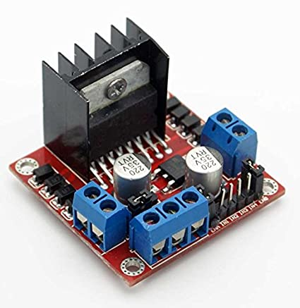 L298N is used as driver IC. Motors are connected to this IC. According to program in μc it drives the left and right motor.

Fig 2.7: Motor Driver Module

* 1. 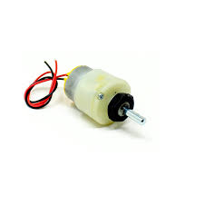**MOTOR:** An electric motor is an electrical machine that converts electrical energy into mechanical energy. Most electric motors operate through the interaction between the motor's magnetic field and electric current in a wire winding to generate force in the form of torque applied on the motor's shaft

# Fig 2.8: DC motor

# CHAPTER-3

**HARDWARE IMPLIMENTATION**

This chapter briefly explains about the hardware implementation of the project. It discusses about design and working of the design with the help of block diagram and circuit diagram and explanation of circuit diagram in detail.

# 3.1. Schematic Diagram

# 

# Fig 3.1 Schematic Diagram

# Fig 3.2 Internal Diagram

# 

* 1. **CIRCUIT DESCRIPTION:**

Basically, the circuit consists of the following blocks: -

● Power supply circuit

* Voltage regulator
* Arduino UNO
* Lithium-ion Battery
* Li-Dar

# 3.2.1 POWER SUPPLY CIRCUIT:

The input to the circuit is applied from the regulated power supply. The a.c. input i.e., 230V from the mains supply is step down by transformer to 12V and is fed to the rectifier. The output obtained from the rectifier is pulsating DC voltage. So, in order to get a pure DC voltage, the output voltage from the rectifier is fed to a filter to remove any a.c components present even after rectification. Now, this voltage is given to a voltage regulator to obtain a pure constant dc voltage.

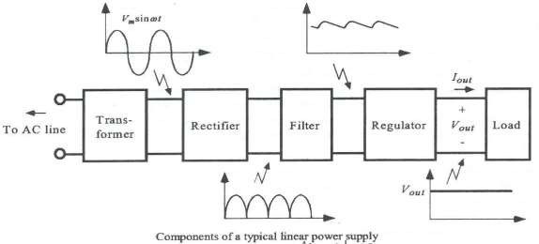

Fig 3.3 Components of a Typical Linear power Supply

# VOLTAGE REGULATOR:

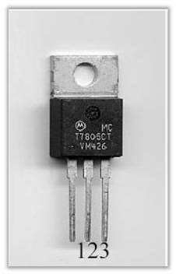As the name itself implies, it regulates the input applied to it. A voltage regulator is an electrical regulator designed to automatically maintain a constant voltage level. In this project, a power supply of 5v and 12v are required. In order to obtain these voltage levels, 7805 and 7812 voltage regulators are to be used. The first 78 represents positive supply and the number 05,12 represents the required output voltage levels

Fig 3.4 IC

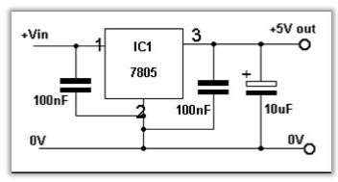

Fig 3.5 circuit Diagram

Fig: 4.2 voltage regulator 7805 e.g. voltages.,7805 (5 V), 7806 (6 V), 7808 (8 V), 7810 (10 V), 7812(12 V), 7815 (15 V), 7818 (18 V), and 7824 (24 V). These devices can handle a maximum output current of 1.5 A if properly heat-sunk. To remove unwanted input or output spikes/noise, capacitors can be attached to the regulator’s input and output terminals.

* + 1. **Arduino UNO**

The Arduino Uno is an open-source microcontroller board based on the Microchip ATmega328P microcontroller and developed by Arduino.cc. The board is equipped with sets of digital and analog input/output (I/O) pins that may be interfaced to various expansion boards (shields) and other circuits. The board has 14 digital I/O pins (six capable of PWM output), 6 analog I/O pins, and is programmable with the Arduino IDE (Integrated Development Environment), via a type B USB cable. It can be powered by the USB cable or by an external 9-volt battery, though it accepts voltages between 7 and 20 volts. It is similar to the Arduino Nano and Leonardo. The hardware reference design is distributed under a Creative Commons Attribution Share-Alike 2.5 license and is available on the Arduino website. Layout and production files for some versions of the hardware are also available.The word "Uno" means "one" in [Italian](https://en.wikipedia.org/wiki/Italian_language) and was chosen to mark the initial release of [Arduino Software](https://en.wikipedia.org/wiki/Arduino_Software). The Uno board is the first in a series of USB-based Arduino boards it and version 1.0 of the Arduino [IDE](https://en.wikipedia.org/wiki/Integrated_development_environment) were the reference versions of Arduino, which have now evolved to newer releases.The ATmega328 on the board comes preprogramed with a [bootloader](https://en.wikipedia.org/wiki/Bootloader) that allows uploading new code to it without the use of an external hardware programmer.

While the Uno communicates using the original STK500 protocol, it differs from all preceding boards in that it does not use the FTDI USB-to-serial driver chip. Instead, it uses the Atmega16U2 (Atmega8U2 up to version R2) programmed as a [USB-to-serial converter](https://en.wikipedia.org/wiki/USB-to-serial_converter).

The Arduino project started at the [Interaction Design Institute Ivrea](https://en.wikipedia.org/wiki/Interaction_Design_Institute_Ivrea) (IDII) in [Ivrea](https://en.wikipedia.org/wiki/Ivrea), Italy. At that time, the students used a [BASIC Stamp](https://en.wikipedia.org/wiki/BASIC_Stamp) microcontroller, at a cost that was a [considerable expense](https://en.wikipedia.org/wiki/Arduino#History) for many students. In 2003, Hernando Barragan created the development platform [Wiring](https://en.wikipedia.org/wiki/Wiring_(development_platform)) as a Master's thesis project at IDII, under the supervision of Massimo Banzi and Casey Reas, who are known for work on the [Processing](https://en.wikipedia.org/wiki/Processing_(programming_language)) language. The project goal was to create simple, low-cost tools for creating digital projects by non-engineers. The Wiring platform consisted of a [printed circuit board](https://en.wikipedia.org/wiki/Printed_circuit_board) (PCB) with an [ATmega](https://en.wikipedia.org/wiki/ATmega)168 microcontroller, an IDE based on Processing, and library functions to easily program the microcontroller. In 2003, Massimo Banzi, with David Mallis, another IDII student, and David Cuartillas, added support for the cheaper ATmega8 microcontroller to Wiring. But instead of continuing the work on Wiring, they [forked](https://en.wikipedia.org/wiki/Fork_(software_development)) the project and renamed it *Arduino*. Early [Arduino](https://en.wikipedia.org/wiki/Arduino) boards used the FTDI USB-to-serial driver chip and an [ATmega](https://en.wikipedia.org/wiki/ATmega)168. The Uno differed from all preceding boards by featuring the ATmega328P microcontroller and an ATmega16U2 (Atmega8U2 up to version R2) programmed as a USB-to-serial converter.

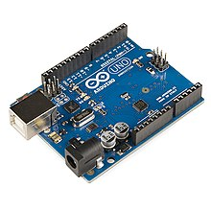

Fig 3.6: **Arduino UNO**

* + 1. **Ultrasonic Sensor**

Ultrasonic sensors work by sending out a sound wave at a frequency above the range of human hearing.  The transducer of the sensor acts as a microphone to receive and send the ultrasonic sound. Our [ultrasonic sensors](https://www.maxbotix.com/SelectionGuide/Selection-Guide.htm), like many others, use a single transducer to send a pulse and to receive the echo.  The sensor determines the distance to a target by measuring time lapses between the sending and receiving of the ultrasonic pulse.

The working principle of this module is simple.  It sends an ultrasonic pulse out at 40kHz which travels through the air and if there is an obstacle or object, it will bounce back to the sensor.  By calculating the travel time and the speed of sound, the distance can be calculated.

Ultrasonic sensors are a great solution for the detection of clear objects.  For liquid level measurement, applications that use infrared sensors, for instance, struggle with this particular use case because of target translucence.

For presence detection, ultrasonic sensors detect objects regardless of the colour, surface, or material (unless the material is very soft like wool, as it would absorb sound.)

To detect transparent and other items where optical technologies may fail, ultrasonic sensors are a reliable choice.

When using multiple sensors in an application, it’s important to connect them in a way that will allow you to avoid issues like crosstalk or any other interference.

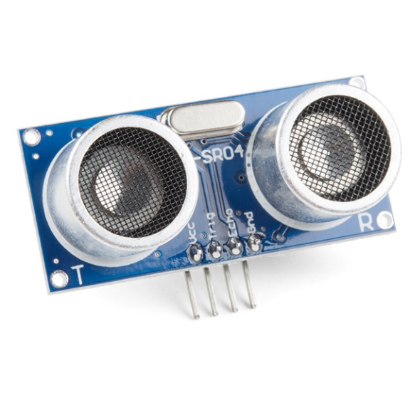To prevent the disruption of the ultrasonic signals coming from your sensor, it’s important to keep the face of the ultrasonic transducer clear of any obstructions.

Common obstructions include:

* Dirt
* Snow
* Ice
* Other Condensation

For this particular use case, we offer our [Self Cleaning sensors.](https://www.maxbotix.com/product-category/all-environments/scxl-maxsonar-wr-products) Fig 3.7 Sensor

They are intended specifically for applications requiring the resistance of condensation in high moisture environments, our self-cleaning function is designed to run continuously in order for the self-cleaning feature to be active.

**3.2.5 Lithium-ion Battery**

A lithium-ion (Li-ion) battery is an advanced battery technology that uses lithium ions as a key component of its electrochemistry. During a discharge cycle, lithium atoms in the anode are ionized and separated from their electrons. The lithium ions move from the anode and pass through the electrolyte until they reach the cathode, where they recombine with their electrons and electrically neutralize. The lithium ions are small enough to be able to move through a micro-permeable separator between the anode and cathode. In part because of lithium’s small size (third only to hydrogen and helium), Li-ion batteries are capable of having a very high voltage and charge storage per unit mass and unit volume.

Li-ion batteries can use a number of different materials as electrodes. The most common combination is that of lithium cobalt oxide (cathode) and graphite (anode), which is most commonly found in portable electronic devices such as cell phones and laptops. Other cathode materials include lithium manganese oxide (used in hybrid electric and electric automobiles) and lithium iron phosphate. Li-ion batteries typically use ether (a class of organic compounds) as an electrolyte.

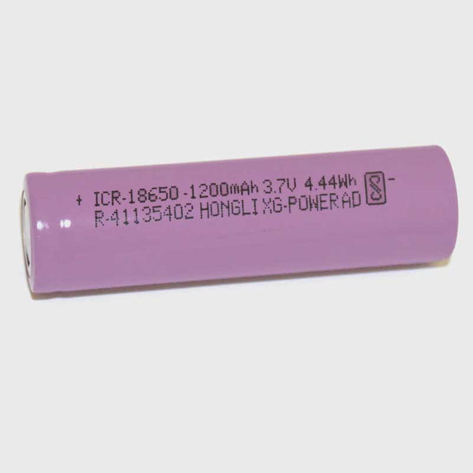

Fig 3.8 Lithium Battery

* **What are some advantages of Li-ion batteries?**

Compared to the other high-quality rechargeable battery technologies (nickel-cadmium or nickel-metal-hydride), Li-ion batteries have a number of advantages. They have one of the highest energy densities of any battery technology today (100-265 Wh/kg or 250-670 Wh/L). In addition, Li-ion battery cells can deliver up to 3.6 Volts, 3 times higher than technologies such as Ni-Cd or Ni-MH. This means that they can deliver large amounts of current for high-power applications, which has Li-ion batteries are also comparatively low maintenance, and do not require scheduled cycling to maintain their battery life. Li-ion batteries have no memory effect, a detrimental process where repeated partial discharge/charge cycles can cause a battery to ‘remember’ a lower capacity. This is an advantage over both Ni-Cd and Ni-MH, which display this effect. Li-ion batteries also have low self-discharge rate of around 1.5-2% per month. They do not contain toxic cadmium, which makes them easier to dispose of than Ni-Cd batteries.

## **What are some disadvantages of Li-ion batteries?**

Despite their technological promise, Li-ion batteries still have a number of shortcomings, particularly with regards to safety. Li-ion batteries tend to overheat, and can be damaged at high voltages. In some cases, this can lead to thermal runaway and combustion. This has caused significant problems, notably the grounding of the Boeing 787 fleet after onboard battery fires were reported. Because of the risks associated with these batteries, a number of shipping companies refuse to perform bulk shipments of batteries by plane. Li-ion batteries require safety mechanisms to limit voltage and internal pressures, which can increase weight and limit performance in some cases. Li-ion batteries are also subject to aging, meaning that they can lose capacity and frequently fail after a number of years. Another factor limiting their widespread adoption is their cost, which is around 40% higher than Ni-Cd. Addressing these issues is a key component for current research into the technology. Finally, despite the high energy density of Li-ion compared to other kinds of batteries, they are still around a hundred times less energy dense than gasoline (which contains 12,700 Wh/kg by mass or 8760 Wh/L by volume).

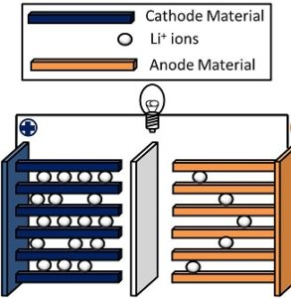

Fig 3.9 Schematic of a lithium-ion battery

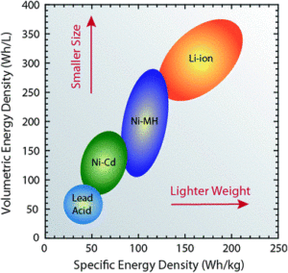

**3.2.6 Lidar Sensor**

LIDAR can measure the distance of a target by illuminating it with light. LIDAR technology is being used in Robotics for the perception of the environment as well as object classification. The ability of LIDAR technology to provide 2D elevation maps of the terrain, high precision distance to the ground, and approach velocity can enable safe landing of robotic and manned vehicles with a high degree of precision.

LIDAR consists of a transmitter which illuminates a target with a laser beam, and a receiver capable of detecting the component of light which is essentially coaxial with the transmitted beam. Receiver sensors calculate a distance, based on the time needed for the light to reach the target and return. A mechanical mechanism with a mirror sweeps the light beam to cover the required scene in a plane or even in three dimensions, using a rotating nodding mirror.

One way to measure the time of flight for the light beam is to use a pulsed laser and then measure the elapsed time directly. Electronics capable of resolving picoseconds are required in such devices and they are therefore very expensive. Another method is to measure the phase shift of the reflected light.

Collimated infrared laser is used to the phase-shift measurement. For surfaces, having a roughness greater than the wavelength of the incident light, diffuse reflection will occur. The component of the infrared light will return almost parallel to the transmitted beam for objects.

The sensor measures the phase shift between the transmitted and reflected signals. The picture shows how this technique can be used to measure distance. The wavelength of the modulating signal obeys the equation:

c = f ∙ τ

where c is the speed of light and f the modulating frequency and τ the known modulating wavelength.

The total distance D' covered by the emitted light is:

D' = B + 2A = B + (θ * τ) / 2π

where A is the measured distance. B is the distance from the phase measurement unit.

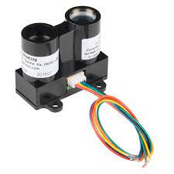

Fig 3.10 Lidar Sensor

# 3.3 HARDWARE MODULES:

The hardware modules of this project are:

* + - Microcontroller
    - Motor driver
    - Motor
    1. **HARDWARE MODULE DISCRIPITON:**

# MICROCONTROLLER (ATMEGA 328p): -

# ATmega328P is one of the high performances AVR technology microcontroller with a large number of pins and features. It is designed by 8-bit CMOS technology and RSIC CPU which enhance its performance and its power efficiency get improved by auto sleeps and internal temperature sensor. This ATmega328P IC comes with internal protections and multiple programming methods which helps the engineers to priorities this controller for different situations. The IC allows multiple modern era communications methods for other modules and microcontrollers itself, which is why the microcontroller ATmega328P usage has been increasing every day

# Features:

|  |  |
| --- | --- |
| Program Memory Type: | Flash |
| Program Memory Size (KB): | 32 |
| CPU Speed (MIPS/DMIPS): | 20 |
| SRAM (B): | 2,048 |
| Data EEPROM/HEF (bytes): | 1024 |
| Digital Communication Peripherals: | 1-UART, 2-SPI, 1-I2C |
| Capture/Compare/PWM Peripherals: | 1 Input Capture, 1 CCP, 6PWM |
| Timers: | 2 x 8-bit, 1 x 16-bit |
| Number of Comparators: | 1 |
| Temperature Range (°C): | -40 to 85 |
| Operating Voltage Range (V): | 1.8 to 5.5 |
| Pin Count: | 32 |
| Low Power: | Yes |

# PIN DIAGRAM:

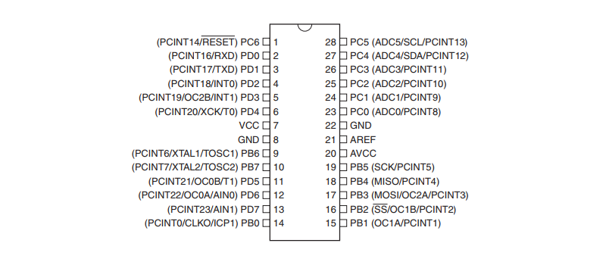

Figure: 3.11 Pin diagram

# PIN DESCRIPTION:

* VCC is a digital voltage supply.
* AVCC is a supply voltage pin for analog to digital converter.
* GND denotes Ground and it has a 0V.

1. Port A consists of the pins from PA0 to PA7. These pins serve as an analog input to analog to digital converters. If analog to digital converter is not used, port A acts as an eight (8) bit bidirectional input/output port.
2. Port B consists of the pins from PB0 to PB7. This port is an 8-bit bidirectional port having an internal pull-up resistor.
3. Port C consists of the pins from PC0 to PC7. The output buffers of port C has symmetrical drive characteristics with source capability as well high sink.
4. Port D consists of the pins from PD0 to PD7. It is also an 8 bit input/output port having an internal pull-up resistor.

| **Pin# Pin** | **Description** | **Pin Function** | **Pin Function Description** |
| --- | --- | --- | --- |
| 1 | PC6 | Reset | When this reset pin goes low the microcontroller & its program gets reset. |
| 2 | PD0 | Digital Pin (RX) | Input pin for serial communication |
| 3 | PD1 | Digital Pin (TX) | Output pin for serial communication |
| 4 | PD2 | Digital Pin | Pin 4 is used as an external interrupt 0 |
| 5 | PD3 | Digital Pin (PWM) | Pin 5 is used as an external interrupt 1 |
| 6 | PD4 | Digital Pin | Pin 6 is used for external counter source Timer0 |
| 7 | Vcc | Positive Voltage | Positive supply of the system. |
| 8 | GND | Ground | Ground of the system |
| 9 | XTAL | Crystal Oscillator | This pin should be connected to one pin of the crystal oscillator to provide external clock pulse to the chip |
| 10 | XTAL | Crystal Oscillator | This pin should also be connected to another pin of the crystal oscillator to provide external clock pulse to the chip |
| 11 | PD5 | Digital Pin (PWM) | Pin 11 is used for external counter source Timer1 |
| 12 | PD6 | Digital Pin (PWM) | Positive Analog Comparator i/ps |
| 13 | PD7 | Digital Pin | Negative Analog Comparator i/ps |
| 14 | PB0 | Digital Pin | Counter or Timer input source |
| 15 | PB1 | Digital Pin (PWM) | counter or timer compare match A. |
| 16 | PB2 | Digital Pin (PWM) | This pin is act as a slave choice i/p. |
| 17 | PB3 | Digital Pin (PWM) | This pin is used as a master data output and slave data input for SPI. |
| 18 | PB4 | Digital Pin | This pin is act as a master clock input and slave clock output. |
| 19 | PB5 | Digital Pin | This pin is act as a master clock output and slave clock input for SPI. |
| 20 | AVcc | Positive Voltage | Positive voltage for ADC (power) |
| 21 | AREF | Analog Reference | Analog Reference voltage for ADC (Analog to Digital Converter) |
| 22 | GND | Ground | Ground of the system |
| 23 | PC0 | Analog Input | Analog input digital value channel 0 |
| 24 | PC1 | Analog Input | Analog input digital value channel 1 |
| 25 | PC2 | Analog Input | Analog input digital value channel 2 |
| 26 | PC3 | Analog Input | Analog input digital value channel 3 |
| 27 | PC4 | Analog Input | Analog input digital value channel 4. This pin can also be used as serial interface connection for data. |
| 28 | PC5 | Analog Input | Analog input digital value channel 5. This pin also used as serial interface clock line. |

* 1. **Applications**

There are hundreds of applications for ATMEGA328P:

* Used in ARDUINO UNO, ARDUINO NANO and ARDUINO MICRO boards.
* Industrial control systems.
* SMPS and Power Regulation systems.
* Digital data processing.
* Analog signal measuring and manipulations.
* Embedded systems like coffee machine, vending machine.
* Motor control systems.
* Display units.
* Peripheral Interface system.

# https://www.theengineeringprojects.com/wp-content/uploads/2017/07/Introduction-to-Atmega328_2.pngBLOCK DIAGRAM:

Fig 3.12 Internal diagram of microcontroller

# MOTOR:

# A direct current (DC) motor is another widely used device that translates electrical pulses into mechanical movement. In the DC motor we have only + and - leads. Connecting them to a DC voltage source moves the motor in one direction. By reversing the polarity, the DC motor will move in the opposite direction. One can easily experiment with the DC motor. For example, small fans used in many motherboards to cool the CPU are run by DC motors. By connecting their leads to the + and - voltage source, the DC motor moves. While a stepper motor moves in steps of 1 to 15 degrees, the DC motor moves continuously.

# 

# 

# Fig 3.13 Internal working of Motor

# Types of DC motor

# DC motors have a wide range of applications ranging from electric shavers to automobiles. To cater to this wide range of applications, they are classified into different types based on the field winding connections to the armature as:

# Self-Excited DC Motor

# Separately Excited DC Motor

# Now, let us discuss the various types of DC Motors in detail.

# Self-Excited DC Motor

# In self-excited DC motors, the field winding is connected either in series or parallel to the armature winding. Based on this, the self-excited DC motor can further be classified as:

# Shunt wound DC motor

# Series wound DC motor

# Compound wound DC motor

**3.3.8 DC Motor**

In a DC motor, if we know the starting position we can easily count the number of steps the motor has moved and calculate the final position of the motor. This is not possible in a DC motor. The maximum speed of a DC motor is indicated in rpm and is given in the data sheet. The DC motor has two rpms: no-load and loaded. The manufacturer’s data sheet gives the no-load rpm. The no- load rpm can be from a few thousand to tens of thousands. The rpm is reduced when moving a load and it decreases as the load is increased. For example, a drill turning a screw has a much lower rpm speed than when it is in the no-load situation. DC motors also have voltage and current ratings. The nominal voltage is the voltage for that motor under normal conditions, and can be from 1 to 150V, depending on the motor. As we increase the voltage, the rpm goes up. The current rating is the current consumption when the nominal voltage is applied with no load, and can be from 25mA to a few amps. As the load increases, the rpm is decreased, unless the current or voltage provided to the motor is increased, which in turn increases the torque. With a fixed voltage, as the load increases, the current (power) consumption of a DC motor is increased. If we overload the motor it will stall, and that can damage the motor due to the heat generated by high current consumption.

# L298N Motor Driver Module:

From microcontroller we cannot connect a motor directly because microcontroller cannot give sufficient current to drive the DC motors. Motor driver is a current enhancing device, it can also be act as Switching Device. Thus, we insert motor driver in between motor and microcontroller. Motor driver take the input signals from microcontroller and generate corresponding output for motor.

# L298N -

This L298N Motor Driver Module is a high-power motor driver module for driving DC and Stepper Motors. This module consists of an L298 motor driver IC and a 78M05 5V regulator. L298N Module can control up to 4 DC motors, or 2 DC motors with directional and speed control

* + 1. **Pin Description**

|  |  |
| --- | --- |
| **Pin Name** | **Description** |
| IN1 & IN2 | Motor A input pins. Used to control the spinning direction of Motor A |
| IN3 & IN4 | Motor B input pins. Used to control the spinning direction of Motor B |
| ENA | Enables PWM signal for Motor A |
| ENB | Enables PWM signal for Motor B |
| OUT1 & OUT2 | Output pins of Motor A |
| OUT3 & OUT4 | Output pins of Motor B |
| 12V | 12V input from DC power Source |
| 5V | Supplies power for the switching logic circuitry inside L298N IC |
| GND | Ground pin |

**Features & Specifications**

* Driver Model: L298N 2A
* Driver Chip: Double H Bridge L298N
* Motor Supply Voltage (Maximum): 46V
* Motor Supply Current (Maximum): 2A
* Logic Voltage: 5V
* Driver Voltage: 5-35V
* Driver Current:2A
* Logical Current:0-36mA
* Maximum Power (W): 25W

### **Brief about L298N Module**

The L298N Motor Driver module consists of an L298 Motor Driver IC, 78M05 Voltage Regulator, resistors, capacitor, Power LED, 5V jumper in an integrated circuit.

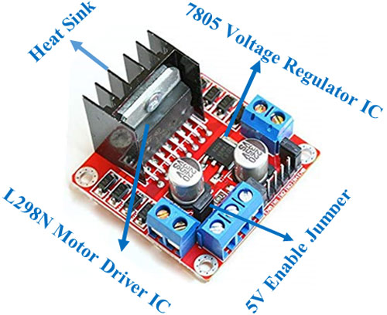

Fig 3.14 Motor Driver Module

78M05 Voltage regulator will be enabled only when the jumper is placed. When the power supply is less than or equal to 12V, then the internal circuitry will be powered by the voltage regulator and the 5V pin can be used as an output pin to power the microcontroller. The jumper should not be placed when the power supply is greater than 12V and separate 5V should be given through 5V terminal to power the internal circuitry.

ENA & ENB pins are speed control pins for Motor A and Motor B while IN1& IN2 and IN3 & IN4 are direction control pins for Motor A and Motor B.

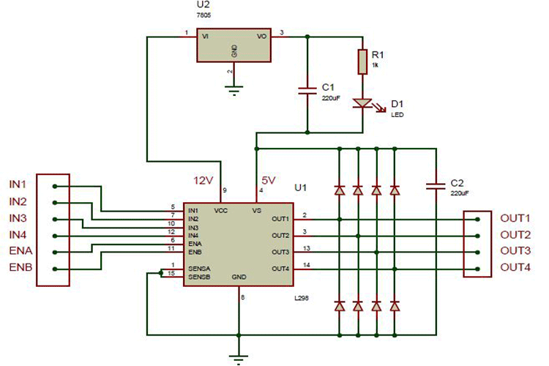

# 

# 

# Fig 3.15 Internal circuit diagram of L298N Motor Driver module is given

The module has two direction control pins for each channel. The **IN1** and **IN2** pins control the spinning direction of the motor A while **IN3** and **IN4** control motor B.

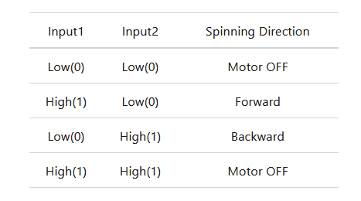The spinning direction of a motor can be controlled by applying either a logic HIGH (5 Volts) or logic LOW(Ground) to these inputs. The below chart illustrates how this is done.

**3.5 MOTOR OUTPUT SYSTEM:**

For moving a robot, we have two dc motors attached to wheels gears.

# 3.5.1 WHY DC MOTORS:

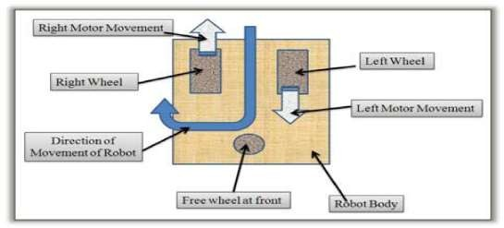DC motors are most easy to control. One dc motor requires only two signals for its operation. If we want to change its direction just reverse the polarity of power supply across it. We can vary speed by varying the voltage across motor. By using two motors we can move our robot in any direction. This steering mechanism of robot is called as **differential drive.**

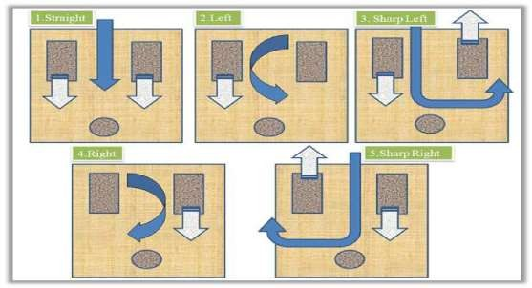 Fig 3.16 Dc motor Control 1

|  |  |  |
| --- | --- | --- |
| **Left Motor** | **Right Motor** | **Robot Movement** |
| Straight | Straight | Straight |
| Stop | Straight | Left |
| Reverse | Straight | Sharp Left |
| Straight | Stop | Right |
| Straight | Reverse | Sharp right |
| Reverse | Reverse | Reverse |

# 

# 4.1 SOFTWARE TOOL REQUIRED:

**CHAPTER-4 SOFTWARE IMPLIMENTATION**

Keil µv3, Preload are the two software tools used to program microcontroller. The working of each software tool os explained below in details.

# PROGRAMING MICROCONTROLLER

A complier for a high-level language helps to reduce production time. To program th AT89S52 microcontroller the keil µV3 is used. The programming is done strictly in the embedded C language.

The compilation of the C program converts it into machine language file (.hex). This is the only language the micro controller will understand, because it contains the original program code converted into hex decimal format. During this step there are some warnings about eventual errors in the program. This is shown in fig. below.

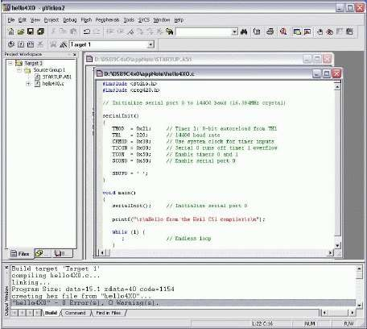

Fig.4.1 Compilation source code

# 4.3 KEIL Compiler

Keil complier is software used where the machine language code is written and compiled. After compilation, the machine source code is converted into hex code which is to be dumped into the microcontroller for further processing. Keil compiler also supports C language code.

# PROLOAD

Preload is software which accepts only hex files. Once the machine code is converted into hex code, that hex code has to be dumped into the micro controller and this is done by the proload. Proload programmer which itself contains a micro controller in it other than the one which is to be programmed. This micro controller has a program in it written in such a way that it accepts the hex file from keil compiler and dumps this hex file into the microcontroller which is to be programmed. As the proload programmer kit requires power supply to be operated, this power supply is given from the power supply circuit designed above. It should be noted that this programmer kit contains power supply section board itself in order to switch on that power supply, a source is required. Thus, this is accomplished from the power supply board with an output of 12V.

# ProLoad Download - Software working as user friendly interface for programmer boards

# 

# Fig 4.2 Proload Software

# Features:

* + 1. Supports major Atmel 89 series devices
    2. Auto identify connected hardware and devices
    3. Error checking and verification in built
    4. Lock of programs in chip supported to prevent program copying
    5. 20-40 pins ZIF socket on board
    6. Auto Erase before writing and Auto verify after writing
    7. Informative status bar and access to latest programmed file
    8. Simple and easy to use
    9. Works on 57600 speed

# CODING:

**#include <LiquidCrystal.h>**

**LiquidCrystal lcd(8,9,10,11,12,13);//RS,EN,D4,D5,D6,D7**

**#define trigPin2 6**

**#define echoPin2 7**

**#define trigPin3 4**

**#define echoPin3 5**

**#define motor1 A0**

**#define motor1a A1**

**#define motor2 A2**

**#define motor2a A3**

**#define lidar A4**

**int rbyte = 0,d=0; // for incoming serial data**

**int front=0;**

**long duration, distance,sensor2,sensor1,sensor3;**

**void setup()**

**{**

**Serial.begin(9600);**

**pinMode(motor1, OUTPUT);**

**pinMode(motor1a, OUTPUT);**

**pinMode(motor2, OUTPUT);**

**pinMode(motor2a, OUTPUT);**

**pinMode(trigPin2, OUTPUT);**

**pinMode(echoPin2, INPUT);**

**pinMode(trigPin3, OUTPUT);**

**pinMode(echoPin3, INPUT);**

**lcd.begin(16, 2);//initializing LCD**

**lcd.setCursor(0,0);**

**lcd.print("..............");**

**lcd.setCursor(0,1);**

**lcd.print("..............");**

**delay(1000);**

**}**

**void forward()**

**{**

**digitalWrite(motor1, HIGH);**

**digitalWrite(motor1a, LOW);**

**digitalWrite(motor2, HIGH);**

**digitalWrite(motor2a, LOW);**

**}**

**void backward()**

**{**

**digitalWrite(motor1, LOW);**

**digitalWrite(motor1a, HIGH);**

**digitalWrite(motor2, LOW);**

**digitalWrite(motor2a, HIGH);**

**}**

**void stopp()**

**{**

**digitalWrite(motor1, LOW);**

**digitalWrite(motor1a, LOW);**

**digitalWrite(motor2, LOW);**

**digitalWrite(motor2a, LOW);**

**}**

**void left()**

**{**

**digitalWrite(motor1, HIGH);**

**digitalWrite(motor1a, LOW);**

**digitalWrite(motor2, LOW);**

**digitalWrite(motor2a, HIGH);**

**}**

**void right()**

**{**

**digitalWrite(motor1, LOW);**

**digitalWrite(motor1a, HIGH);**

**digitalWrite(motor2, HIGH);**

**digitalWrite(motor2a, LOW);**

**}**

**//-----------------------------------------------------------------------//**

**void loop()**

**{**

**front=analogRead(lidar);**

**ultrasensor(trigPin2, echoPin2);**

**sensor2 = distance;**

**delay(2);**

**ultrasensor(trigPin3, echoPin3);**

**sensor3 = distance;**

**delay(2);**

**straight();**

**Serial.print("sensor1=");**

**Serial.println(front);**

**//Serial.print("sensor2=");**

**//Serial.println(sensor2);**

**//Serial.print("sensor3=");**

**//Serial.println(sensor3);**

**// int frontt=front/4;**

**lcDClear();**

**lcd.setCursor(0, 0);**

**lcd.print("S1 S2 S3");**

**lcd.setCursor(0, 1);**

**lcd.print(sensor2);**

**lcd.setCursor(6, 1);**

**lcd.print(front);**

**lcd.setCursor(13, 1);**

**lcd.print(sensor3);**

**delay(100);**

**}**

**void straight()**

**{**

**if(front > 100)**

**{**

**direction_change();**

**}**

**else**

**{**

**forward();**

**direction_change1();**

**}**

**}**

**void direction_change()**

**{**

**if((sensor2 <= 35 && sensor2 >= 2)&&(sensor3 <= 35 && sensor3 >= 2))**

**{**

**stopp();**

**delay(1000);**

**backward();**

**delay(2500);**

**right();**

**delay(1000);**

**}**

**else if(sensor2 <= 40 && sensor2 >= 2)**

**{**

**right();**

**}**

**else if(sensor3 <= 40 && sensor3 >= 2)**

**{**

**left();**

**}**

**else**

**{**

**left();**

**}**

**}**

**void direction_change1()**

**{**

**if(sensor2 <= 20 && sensor2 >= 2)**

**{**

**right();**

**}**

**else if(sensor3 <= 20 && sensor3 >= 2)**

**{**

**left();**

**}**

**}**

**void ultrasensor(int trigPin,int echoPin)**

**{**

**digitalWrite(trigPin, LOW); // Added this line**

**delayMicroseconds(2); // Added this line**

**digitalWrite(trigPin, HIGH);**

**delayMicroseconds(10); // Added this line**

**digitalWrite(trigPin, LOW);**

**duration = pulseIn(echoPin, HIGH);**

**distance = (duration/2) / 29.1;**

**}**

**CHAPTER – 5**

**FUTURE SCOPE & RESULT**

**5.1 FUTURE SCOPE**

Traffic-sign recognition (TSR) is a technology by which a vehicle is able to recognize the traffic signs put on the road e.g. "speed limit" or "children" or "turn ahead". This is part of the features collectively called ADAS. The technology is being developed by a variety of automotive suppliers. It uses image processing techniques to detect the traffic signs. The detection methods can be generally divided into color based, shape based and learning based methods.

Traffic signs can be analyzed using forward-facing cameras in many modern cars, vehicles and trucks. One of the basic use cases of a traffic-sign recognition system is for speed limits. Most of the GPS data would procure speed information, but additional speed limit traffic signs can also be used to extract information and display it in the dashboard of the car to alert the driver about the road sign. This is an advanced driver-assistance feature available in most high-end cars.

Modern traffic-sign recognition systems are being developed using convolutional neural networks, mainly driven by the requirements of autonomous vehicles and self-driving cars. In these scenarios, the detection system needs to identify a variety of traffic signs and not just speed limits GPS (Global Positioning System) equipment has lent itself to more accurate and reliable tele location systems. GPS signals are impervious to most electrical noise sources and don't require the user to install an entire system. Usually only a receiver to collect signals from the satellite segment is installed in each vehicle and radio or GSM to communicate the collected location data with a dispatch point.

Large private tele location or AVL systems send data from GPS receivers in vehicles to a dispatch center over their private, user-owned radio backbone. These systems are used for businesses like parcel delivery and ambulances. Smaller systems which don't justify building a separate radio system use cellular or PCS data services to communicate location data from vehicles to their dispatching center. Location data is periodically polled from each vehicle in a fleet by a central controller or computer. In the simplest systems, data from the GPS receiver is displayed on a map allowing humans to determine the location of each vehicle. More complex systems feed the data into a computer assisted dispatch system which automates the process.

**5.2 RESULT & CONCLUSION**

Many drivers are ready for the arrival of self-driving cars, which will cut down on the frustration and irritation of having to constantly pay attention in traffic or on long road trips, among other benefits. This self-driven can also be used as patrol cars, distance measurement at big level, spy robot and many more different and amazing features — including some in our own auto.

The path is still challenging, facing several issues. Awareness of the environment remains the biggest challenge to reliable, smooth, and safe driving. There are number of research questions covering a wide scope that will need to be addressed and answered, including but not limited to customer acceptance, societal impacts, communication technologies, ethical issues, planning, standards, and policy. Software challenges like system security and integrity have also emerged as serious issues to be addressed. These in turn have a number of policy implications including the challenge for policymakers to streamline and regulate many diverse vehicles with different operating constraints. It is also of paramount importance for policymakers to ensure that drivers understand these vehicles’ capabilities and can operate them safely. One of the challenges ahead is to connect several intelligent vehicles to each other and to the infrastructure which gives rise to the application of Big Data, a topic concerned with the processing and analysis of large datasets. In this paper, we shed light on transport related themes that are directly or indirectly and positively and negatively affected by emerging AV technology.

**5.3 PROJECT PHOTOS**

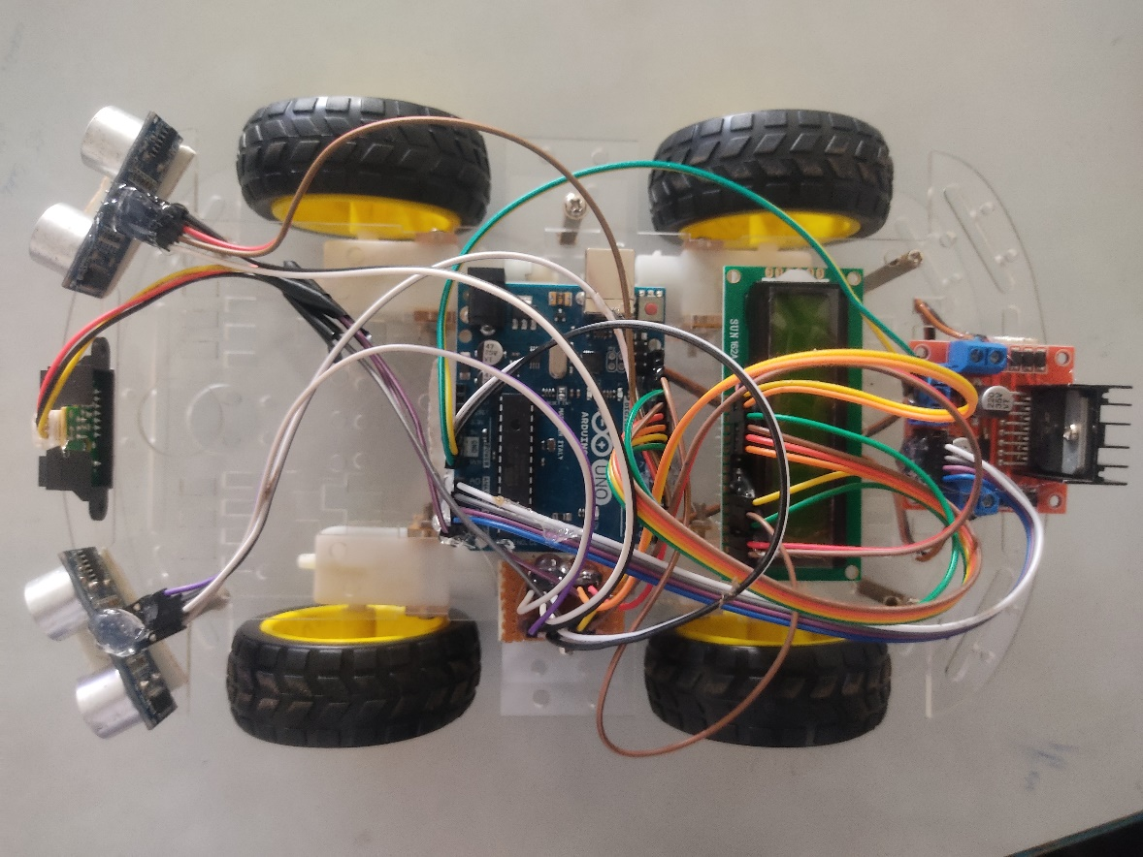

Fig 5.1 Project photo 1

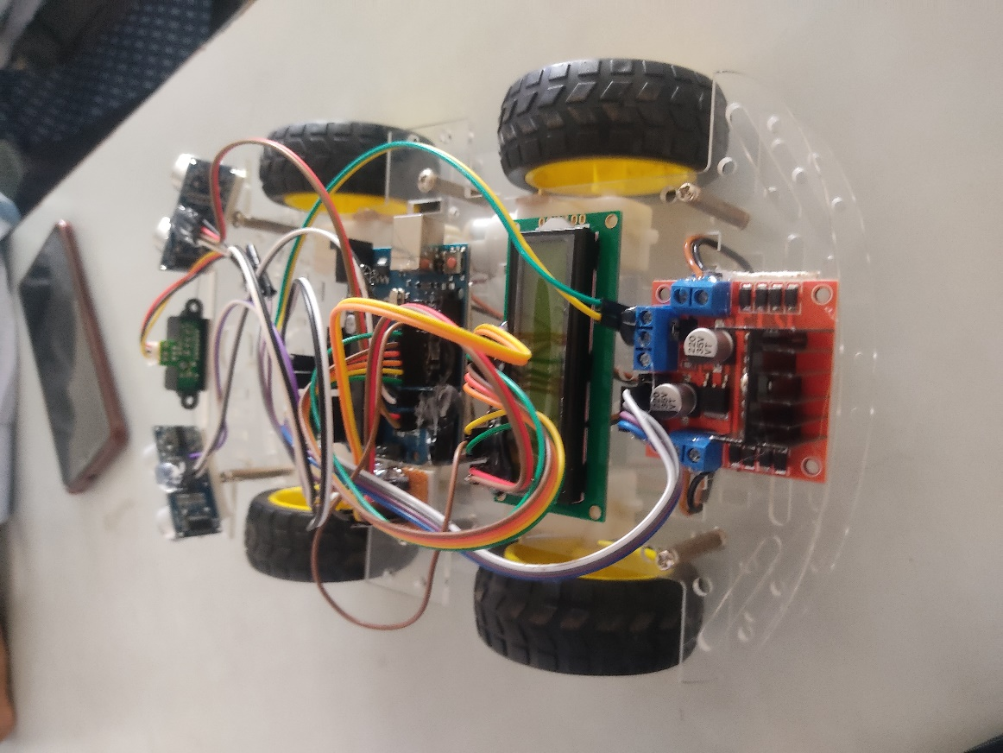

Fig 5.2 Project Photo 2

# 

# Chapter - 6

# REFERENCES

# 

**10.** **REFERENCES**

[1] Developments in the Last Century, the Present Scenario, and the Expected Future of Autonomous Vehicle Technology. Proceedings of the 12th International Conference on Informatics in Control, Automation and Robotics. Doi:10.5220/0005540501910198.

[2] Thorpe, C., Hebert, M., Kanade, T. and Shafer, S., “Vision and Navigation for the Carnegie Mellon Nav lab”, High Precision Navigation, pp. 97-122, doi:10.1007/978-3-642-74585-06.

[3] Ryan, M., “The Future of Transportation: Ethical, Legal, Social and Economic Impacts of Self-driving Vehicles in the Year 2025”, Science and Engineering Ethics, (2019), doi: 10.1007/s11948-019-00130-2.

[4] Levinson, J., Askeland, J., Becker, J., Dolson, J., Held, D., Kammel, S. and Thrun, S., “Towards fully autonomous driving: Systems and algorithms”, 2011 IEEE Intelligent Vehicles Symposium (IV), (2011), doi:10.1109/ivs.2011.5940562.

[5] Dethe, S. N., Shevatkar, V. S. and Bijwe, R. P., “Google Driverless Car”, International Journal of Scientific Research in Science, Engineering and Technology, (2016).

[6] Asvadi, A., Premebida, C., Peixoto, P. and Nunes, U., “3D Lidar-based static and moving obstacle detection in driving environments: An approach based on voxels and multi-region ground planes”, Robot, Auton. Syst., vol. 83, (2016), pp. 299-311.

[7] Zhao, G., Xiao, X., Yuan, J. and Ng, G. W., “Fusion of 3D-LIDAR and camera data for scene parsing”, J. Vis. Commun. Image Represent, vol. 25, (2014), pp. 165-183.

[8] Moosmann, F., Pink, O. and Stiller, C., “Segmentation of 3D lidar data in non-flat urban environments using a local convexity criterion”, In Proceedings of the 2009 IEEE Intelligent Vehicles Symposium, Xi’an, China, (2009) June 3-5, pp. 215-220.

[9] Park, H., “Implementation of Lane Detection Algorithm for Self-driving Vehicles Using Tensor Flow”, In book: Innovative Mobile and Internet Services in Ubiquitous Computing, pp. 438-447, DOI: 10.1007/978-3-319-93554-6_42

[10] Shao, F., Wang, X., Meng, F., Rui, T., Wang, D. and Tang, J., “Real-Time Traffic Sign Detection and Recognition Method Based on Simplified Gabor Wavelets and CNNs. Sensors”, (2018), Doi: 10.3390/s18103192.

[11] Research on traffic sign detection algorithm based on deep learning [Quan Wang Weiping Fu First published: 03 August 2018] <https://doi.org/10.1002/cpe.4675>.

[12] Wu, B., Iandola, F., Jin, P. H. and Keutzer, K., “SqueezeDet: Unified, Small, Low Power Fully Convolutional Neural networks for Real-Time Object Detection for Autonomous Driving”, IEEE Conference on Computer Vision and Pattern Recognition Workshops (CVPRW), (2017), DOI: 10.1109/CVPRW.2017.60.

[13] Kelly, A., “Mobile Robotics”, Cambridge University Press: New York, NY, USA, (2013)

# PLAGIARISM REPORT

|  |  |
| --- | --- |
| DATE | Sunday, May 29, 2022 |
| WORDS | 894 Plagiarized Words / Total 7450 Words |
| SOURCE | More than 125 Sources Identified. |
| REMARK | Low Plagiarism Detected - Your Document needs Optional Improvement. |

# 